

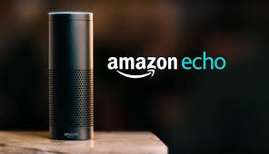

**New Product Development**

**Term Paper**

**On**

**AMAZON ECHO POWERED BY ALEXA**

**By**

***Sanchita Ubale***

**Master of Science in Management of Technology**

**New York University**

Table of Contents

Executive Summary 2

Product Overview 2

Opportunity Identification and Selection 2

Product Innovation Charter 3

SWOT (Strength, Weakness, Opportunity, Threat) 5

New Product Category 6

Concept Generation 6

Situation Analysis 6

Competitor Analysis 6

Customer Analysis 7

The Product Concept 8

Analysis of Product Attributes 8

Concept Evaluation 9

Adopters category 9

ATAR model 10

Sales Forecasting and Financial Analysis 11

Full Screen Test 12

Development 12

Contributions of Design to New Product Process 12

Project Feasibility 14

Product Use Testing 15

Launch 15

First Mover/Second Mover Category 15

Product Positioning 16

Branding and Packaging 17

Concerns faced by Echo 18

Concluding statements 19

References 20

# Executive Summary

## Product Overview

Amazon being tagged as an E-commerce and cloud computing based company, its smart products are well recognized as well. Amazon Echo (known as “Echo”), is considered one of Amazon’s innovations (Amazon, 2017). It was the first-generation smart speakers developed by Amazon.com. It connects to the voice-controlled intelligent personal assistant service called “Alexa”. Operating on Fire OS, it requires voice commands to function.

Alexa can be called the heart of Echo. Connected through Wi-Fi and Bluetooth, voice interaction, setting alarms, making to-do lists, playing audiobooks, music playback, streaming podcasts, and telling weather, traffic and other real-time information are some of the features it can perform. It can behave as a home automation hub by controlling several smart devices. Echo provides hands-free voice control for Amazon Music, Prime Music, Pandora, iHeartRadio, and TuneIn.

Amazon first generation Echo was made available to its prime members in November 2014, and it was launched to the rest of the market in June 2015 (same year in UK (September) and Germany (October)). Since it was a first-generation model, it had scope for improvement and thus, more improved models were developed in the later years such as Echo Dot, Amazon Tap, Echo Look, Echo Show, Echo Spot, and Echo Plus. (Wikipedia, 2017)

# Opportunity Identification and Selection

The virtual assistant technology is prevalent for a long time in the industry with technology giants like Apple, Google, Microsoft capitalizing on this technology and powering their products through it. Apple power’s its devices through Siri, Microsoft through Cortana and Google devices are powered by Google Voice Assistant. Alexa, the driving force behind Amazon Echo, is a Voice Assistant by Amazon.

The idea for the development of Echo was conceived when Dave Isbitski, the chief developer evangelist for Echo and Alexa realized that there was a need for a unified device to control smart home devices setting an **external mandate**. He mentioned that “It's just that there had been no good way to control them — asking users to pull out a remote or even a smartphone app just to turn their lights on and off was too frustrating for many” says Isbitski (Weinberger, 2017). This also allowed them a first mover advantage as there was no similar product in the market that allowed users to control other devices through voice.

Steve Bezos, the CEO of the company also set very high standards for the Echo as **internal mandates** demanding the team to reduce the latency (the time it took for the device to respond) of the product to just one second as this had to be a remarkable product the company was trying to invent.

## Product Innovation Charter

**Focus:** The company aims to take the lead and become a first mover to develop a unified device in terms of a smart speaker to control smart home devices using the existing virtual assistant technology which is prevalent for a long time in the industry. The management sees an opportunity for such a breakthrough device as many smart device users expect an easier solution to unification of all connected smart devices and voice assistant technology would be the cornerstone of the product. A team of specialized R&D experts from the Lab126 will work towards making this a reality by using the laboratory’s existing technological prowess and the expertise of launching products like Kindle Fire Tablet, Fire HDX & similar products.

**Goals/Objectives: As any other new to the world product,** the firm **aims to be a first mover** to introduce the product to the market and capitalize early on the **market share** to compete with leading competitors like Google, Apple have access to the technology who have the capability to introduce it into their devices. **True customer acceptance** holds the key since the product is to deliver a superior experience by incorporating voice recognition in a smart speaker which has not been attempted before. Its features in terms of latency and quality of responses are to be its unique selling points and create a **competitive advantage for the firm**. **Time to market is critical** as the voice recognition technology is prevalent amongst competitors and some have already incorporated it in a mobile device like Apple’s Siri. It is crucial for the company to release a product early into the market to maintain leadership position and increase market share amongst competitors.

**Guidelines:** The voice recognition technology is the future and the company wants to be a leader and gain competitive advantage by being **first-to-market.**  The CEO of the company has also set very high standards for the team to **reduce the latency (the time it took for the device to respond) of the product** to just one second as this had to be a remarkable product the company was trying to invent. To **create a brand image and capitalize on the voice recognition technology**, the product should be screen-less allowing user interaction only through voice.

## SWOT (Strength, Weakness, Opportunity, Threat)

|  |  |
| --- | --- |
| **STRENGHTS**   * Largest online retailer * Strong presence worldwide * Customer oriented * Brand recognition & loyalty amongst customers * Global presence with suppliers’ network worldwide | **WEAKNESSES**   * Outsourcing delivery costs * First mover strategy incurred additional costs in product promotion to educate customers * No existing market to perform market testing operations * Risk of product being perceived as an ordinary speaker |
| **OPPORTUNITIES**   * Successful product line extensions * Low cost structure of the product helps in achieving scale * Sponsored advertising through the product platform that adds to the revenue stream * Gain mindshare by creating a niche by selling a unique experience rather than just a product. | **THREATS**   * Intensive competition from other competitors in the market like Apple & Google in terms of smart devices * Data security issue with connected smart devices as data collected from user interactions may be hacked * Open source platform allowing Alexa integration with third party devices may lead to violation of intellectual property rights or theft of property. |

## New Product Category

The **firm aims to be a first mover** to introduce the product to the market and **capitalize early on the market share** as other leading competitors like Google, Apple have access to the technology and have the capability to introduce it into their devices. The company catered to a wider range of customers in the US targeting the Millennials and Generation X tech savvy audiences who preferred a connected lifestyle through in-home convenience to **increase profits, by selling products at scale in the US**.

**True customer acceptance** was key since the product was to deliver a superior experience by incorporating voice recognition in a smart speaker which has not been attempted before. Its features in terms of latency and quality of responses were to be its unique selling points and **create a competitive advantage for the firm**. **Time to market was critical** as the voice recognition technology was prevalent amongst competitors and some had already incorporated it in a mobile device like Apple’s Siri. It was crucial for the company to release a product early into the market to maintain leadership position and increase market share amongst competitors. This makes it a **new to the world product**.

# Concept Generation

## Situation Analysis

### Competitor Analysis

The IPA (Intelligent Personal Assistant) that powers the Echo is Alexa, which stands rival to another competing IPA’s like Apple’s Siri, Microsoft’s Cortana and Google Now. Though these IPA’s can be a direct threat to Amazon’s Alexa which is the cornerstone of the Echo product, the competitors had not integrated this technology in a smart speaker like Amazon’s Echo which was first of its kind. Amazon Echo continues to dominate the market post it’s launch selling approximately 15 million units till date accounting for more than 70% of the 35.6 million users of voice-enabled speakers in the US in 2017. (Dunn, Amazon's Echo isn't going to give up its lead anytime soon, 2017)

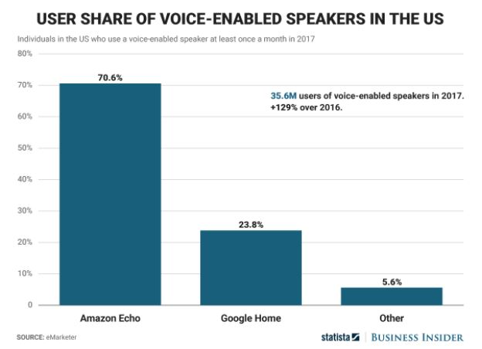

### Customer Analysis

The voice recognition technology has given rise to a still evolving need for digital assistants and Amazon Echo is a pioneer that falls in this category. The electronics industry concerning IPA (intelligent personal assistant) showed 1.4 percent growth in 2014 reaching a value of $95,553.8Million (MarketLine, 2015). The target market for Echo was upper middle-class individuals in the age group of 35-50 who adapt new technologies. According to the development team, the product was to reduce consumer pain by unifying all smart devices and providing a one-stop solution providing a closed loop ecosystem to control user devices and appliances.

## The Product Concept

**Form:** A smart speaker with voice recognition. Keeping an office or a home setting in mind surrounded by smart devices and appliances, the product was to be compact like any other speaker.

**Technology:** To emphasize the superiority of its speech recognition system, the product was to be designed without screens to allow interaction only through voice. The latency (the time it took for the device to respond) of the product was targeted to be just one second as this had to be a remarkable product the company was trying to invent. The product should allow multiple users to interact effectively.

**Need/Benefit:** The product serves as a smart ecosystem allowing control over a wide range of internet connected devices allowing users to perform day-to-day activities like, playing a song, controlling smart lightings and appliances, shop online, read newspaper etc.

The product would also allow the company to integrate its e-commerce distribution system making online purchases more convenient. It creates a new opportunity for potential brand partnerships with merchandisers and brands to sell products through the product platform where the company can charge higher for a particular brand to show up earlier in the list of suggestions for a user’s specific query.

## Analysis of Product Attributes

Given the fact that the product had to be a smart speaker, something that was new to the markets, it was crucial for the team to develop the product that looked like a speaker, so it can be positioned as one at the same time clearly highlighting the smart features it entails and create a unique value proposition for itself. Some of the product attributes that would have been taken into consideration during the concept generation stage are:

|  |  |  |
| --- | --- | --- |
| **Benefit** | **Function** | **Feature** |
| * Reduced effort in performing day-to-day activities * Read aloud feature that can aid the visually impaired to listen to news, articles or emails read by the device * Two in one: speaker with smart features. * Future scope: Can be optimized as a home automation gadget | * Voice recognition in terms of cognition * Multiple user support * Connectivity with other smart devices * Communication with third party services like taxi, food etc. | * Responsiveness of the device to user voice in terms of latency * The accuracy of the responses * Attractive design * Easy to place anywhere in a home or office setting * Quality of the Speaker * Ease of use |

# Concept Evaluation

## Adopters category

Amazon Echo was a first mover in the context to smart speakers. Their target market were **Innovators and Early adopters**. With the increasing popularity of AI and advancement in Amazon Web Services, Echo was built to attract an entire new market segment. Echo was introduced at a price of $179.99 for the first-generation model in the US. We feel that with the advanced model releases within 2 years of its first-generation model launch, makes Echo try to cross the chasm and target **early majority** market segments after 2-3 years of its final launch.

## ATAR model

For developing ATAR model, post-trial data is required as input. Since Amazon Echo is a new-to-the-world product, many of the input parameters need to be estimated based on Amazon’s market share and other sources. For ATAR sales forecast, since the product was targeted initially at the US prime members only, the potential market size was 50M US prime users in 2015.

1. Awareness: We are considering percent awareness as 90%, as Amazon followed a direct marketing approach initially through its website, promotional emails, and newsletters. Also, the remaining 10% users could not be reached due to email rebounce or other reasons.
2. Trial: We are assuming the trial rate as 30% since it is a new-to-the-world product. The users will be innovators and early adopters which constitute only a small percentage of the total market segment for Amazon.
3. Availability: The percent availability will be 100% as Amazon initially was a direct seller of the product.
4. Repeat: We are considering the repeat purchase rate as 15% as it was a luxury product which was marked at a price of $179.99 during its launch.

As per the ATAR formula, the forecasted sales for the 1st year (2015) will be

= Potential market size x Awareness x Trail rate x Availability x Repeat purchase rate

= 50,000,000 x 0.90 x 0.30 x 1 x 0.15

= 2,025,000

= **2 Million Approx. (2015 sales)**

*The actual product sales in 2015 were approximately 15% higher that our predicted ATAR model.*

## Sales Forecasting and Financial Analysis

As the product hit the markets in June 2015, it grossed total sales of 2.4m units by the end of the year. The year 2016 is when the product picked up momentum achieving record sales of 5.2m units (Dunn, It’s been a good year for the Amazon Echo, 2016). As other variants like the Amazon Echo Dot priced at $49.99 was introduced to the Echo product line in 2017, the company saw a sharp growth in sales in 2017 with being a leader in market share of smart speakers.

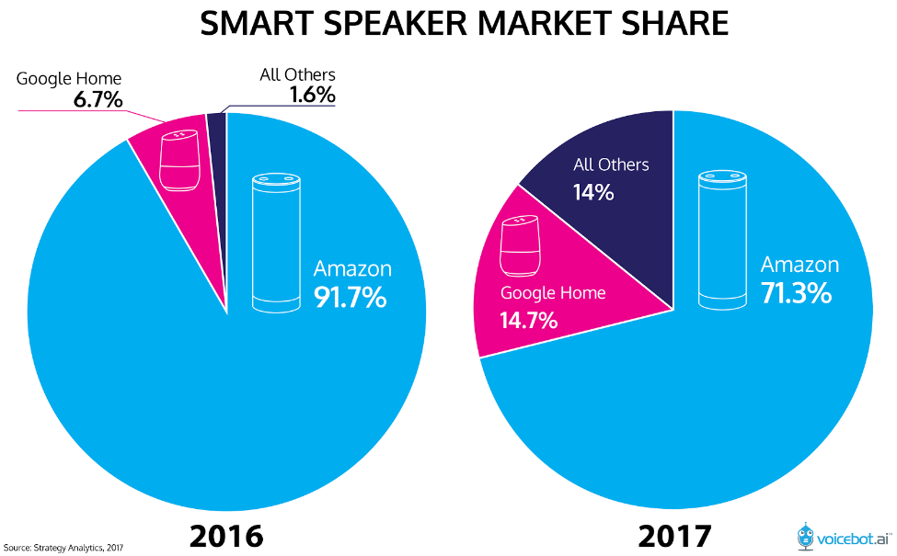

According to a survey by RBC capital markets, by 2020, Amazon could have 500 million active customers globally. With a 40 percent adoption rate in the U.S. and 25 percent internationally, this would mean 60 million Alexa devices sold by that year (Kharpal, 2017).

## Full Screen Test

Full screen test allows us to test the feasibility of the new product. Amazon Echo could be tested over full screen:

* One good trait about Amazon is that it had a dedicated team for development of Echo, that is, Lab126 Project C (idea generation) and D (development). Lab126 is a state-of-the-art facility created by Amazon to develop its products. After the failure of Project B (Fire Phone), the lab resources were completely allocated to project Echo. This helped them focus only on the current product and its related service Alexa.
* This unique team structure got the latency period for Alexa reduced, which made it superior than another virtual assistant (Kim, 2016). In terms of technical feasibility of the product, the team realized earlier on that latency was an important attribute that needs to be addressed in order for Echo to gain a competitive advantage.
* It encouraged communication among the Lab126 researchers and the senior management. During the development of Echo, everyone at Lab126 were skeptical about the product as it was a very unusual product for Amazon to produce. But, Bezos who was the CEO of Amazon, strongly believed in the idea of this smart speaker and moved forward with the product development.

Thus, full screen helped them to overcome the technical glitches in order to make it a more efficient and perfect product as per the CEOs requirement.

# Development

## Contributions of Design to New Product Process

There are various contributions of design to the new product process. These designs contributions help achieve the new product goals. According to our research, Amazon Echo had the following considerations:

***Design for Ease of Manufacture:*** Alexa is said to be the soul of Echo. It is the powerhouse of the smart speaker. Alexa is an AI technology developed by Amazon, which was first used in Echo and then latter devices. Amazon is using Alexa service as **product platforming** for its devices such as smart speakers, TVs and media boxes, phones and tablets, smart homes, wearables, etc. (Wikipedia, 2017)

***Design for Differentiation:*** Echo was born out of attempts to expand Amazon’s device portfolio beyond kindle e-reader (Wikipedia, 2017). Being first of its kind, Amazon opted to step in the business of smart speakers. They focused on quality and price point in factoring their product.

***Design to Meet Customer Needs:*** One of Amazon’s core competency is customer satisfaction and their devices try to meet its competencies. The want for a user-friendly device which blends in well with the daily routine and home automation has been prevalent since ages. Amazon aimed to satisfy the user wants by being the first mover for smart speakers. It was **user -oriented** and had **universal design**.

***Design to Support Corporate Identity:*** Amazon had its own intelligent personal assistant developed, that were used in Echo and other devices to follow. It did not collaborate with other tech giants like Apple (who has Siri already in place) in order to maintain its brand identity in the market. Also, the packaging used for Echo and other product lines where similar which represented a sense of oneness.

***Design for the Environment:*** Amazon has been investing in “Frustration Free Packaging” since 2008. It is in support of green design, that is, 100% recyclable and less packaging waste involved. They have been using this packaging for almost all their products including Echo. It could be counted towards the environmental contribution as a part of corporate social responsibility.

***Design for Competitive Advantage:*** Amazon has always faced major competition from Apple, Google, etc. at various levels in the market. With existing technology at Apple such as Siri, it was just not enough to launch its very own AI service. Echo was a result of a first mover strategy. They realized the need amongst the customer segment for smart devices like speakers which would allow personal interactions with the device in a home or an office setting. It was a mode of entertainment as well as functional assistance. Being first in the market gave Amazon a head start with their smart speakers.

## Project Feasibility

There are three feasibility criteria that needs to be analyzed in any new product process, namely, marketing criteria, technical criteria, and financial criteria.

**Market feasibility:** There are virtual assistants present in the market. But, incorporating this virtual assistant service in a physical device that is friendly, home/ and office oriented gives it a more appealing positioning statement. People will be attracted to the newness of this device since it is a first mover.

**Technical feasibility:** Echo is smart because of Alexa. Alexa is the heart of this smart speaker. The product team has been focusing on the development of Alexa to reduce its latency period as well as make it more intelligent and user-friendly feeding in an extensive amount of data to make smart real-time decisions and increase responsiveness and accuracy. Amazon plans to create a universal design for its users.

**Financial feasibility:** The pricing strategy for Echo in the initial years was formed with innovators and early adopters segment in mind. Its introductory price was set for $179.99 in U.S. In the later years, as newer and improved versions of Echo, the price could be dropped in comparison with the product improvements. Also, the customer segment in 2-3 years after launch will be early majority and late majority. Thus, the reduced pricing strategy will work in the product’s favor.

## Product Use Testing

The R&D team of Amazon Echo used the ‘Wizard of Oz testing’ technique to measure the product effectiveness and responses which involves human interaction with the device to simulate the responses of the device. The wizard would sit back in a room and would answer to questions asked to it and a set of common questions were prepared and a script was provided to users available for testing. The users would then ask the questions from the script and the data regarding response times and accuracy of the responses was recorded for further improvements to the product. Voice was to be the backbone of the device and team focused a great deal of attention in making it as perfect as possible in terms of latency and accuracy.

# Launch

## First Mover/Second Mover Category

With the Amazon Echo, the company was the first to fully incorporate the voice recognition technology and explore its potential to perform day-to-day activities like playing music, reading the news and order groceries through a closed loop ecosystem of internet connected devices and appliances. It allowed them to install a user base which is much higher as compared to its next contender, Google, by capitalizing on its existing customer base of amazon website users. Its 10,000 plus skills on its application base has allowed Amazon Echo to take the lead in terms of market share and revenue, selling over 5 million devices by 2016.

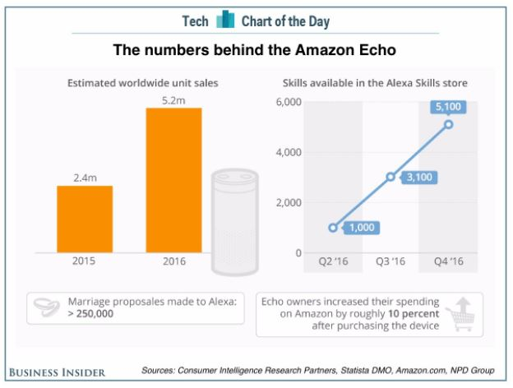

## Product Positioning

The company positioned the product as an intelligent, voice-controlled household appliance that could play music, read the news aloud and order groceries - all by simply letting users talk to it from anywhere in the house (Kim, 2016). According to a company spokesperson, about 40% of the people with whom the product was tested had a music-related intent when they first tried the product. This helped the team focus on its music features at the same time made them wary about not having their product to be perceived as just another speaker ignoring its other smart features. They realized that music was the focal point of positioning this product. Echo was introduced at a price of $179.99 for the first-generation model in the US targeting the Millennials and Generation X tech savvy audiences who preferred a connected lifestyle through in-home convenience.

## Branding and Packaging

**Brand Management:** Brand management becomes important as brand equity and global brand leadership is associated with it. Amazon has created a world-wide presence in the past years since its inception. This makes it a global brand and Amazon’s first of its kind, smart speakers were a great source to strengthen the brand value among the customers.

The Echo team spend a lot of effort in designing the logo and brand usage. Echo was targeted for the innovators and early adopters in its initial year. These adopter categories consist of risk takers and opinion leaders. The branding needs to be effective enough to attract these segments. While designing Alexa logo, it huge amount of consideration was given to various features such as margin and minimum size, color, imagery, app tile, app button, etc. Since Echo is incomplete without Alexa, these all factors mattered a lot in the Echo product launch.

Being a global brand, the new product needed a good name that will help in standardizing the product in the global market. It provides a further step for global brand leadership in the smart speaker category. The initial name printed on the boxes was Amazon Flash. The hardware division at Lab126 disliked the name, yet the CEO Jeff Bezos believed in it. They wanted to feature the “wake word” on the box. This led to many discussions and meeting. Hence, the device was called “Echo” and the wake word was “Alexa”. The users could choose to change the wake word to “Amazon” or “Echo” later. (Brustein, 2016)

**Packaging:** Packaging is a very powerful element when it comes to competitive advantage. In giant companies like Amazon, there are other products for which it has created and maintained a standard packaging design. Almost all the consumers recognize this design, irrespective of their generation.

Amazon has distinguished themselves from other packaging design by creating “Frustration-Free Packaging” concept (Amazon, 2017). It aligns with the design contribution to environment. Furthermore, it serves the various roles of packaging, that is, containment (sometimes include all three types of packaging – primary, secondary, tertiary), safety (package includes air bags and bubble sheet wrapping), protection (protective packaging – lab tested packaging design), display (attracts attention of the package receiver through its brand logo), information (communicated with the customer whether it’s a normal product or Alexa-based product) and persuasion. (Crawford & Di Benedetto, 2015)

Amazon uses the **family packaging strategy** for its products where they use a standard design to integrate the packaging of several different products. In context to Echo, there were packaging recommendations by Amazon product management team. They recommended to communicate the integration of Alexa on the exterior face of the package. “Amazon Alexa Enabled” must be displayed on the outside of the package. In addition to this, they suggested to use the tag line “Just Ask” for hands-free, “Just Press-and-Ask” for a press-and-hold Alexa experience, and “Just Tap-and-Ask” for touch-based Alexa experiences to delineate how customers should interact with Alexa (Amazon Alexa Developer, 2017).

# Concerns faced by Echo

The biggest concern faced by Amazon Echo was invasion of privacy, which is associated with all the smart devices. Echo and Alexa together are considered more powerful as they can work through the security protocols that are used for online shopping and transactions; using cloud services via AWS. Furthermore, it might access our bank information and personal conversations, giving access to hackers and fraud companies (Skilton, 2016). In generality, this technology falls under narrow artificial intelligence. This itself makes it powerful. Hence, it is important to control the power such intelligent things are offering to us today.

# Concluding statements

The CEO of the company envisioned the development of a product which could ease customer pain through state of the art voice recognition technology by creating a unified device to control smart home appliances. This aligned with the company’s mission statement which puts customer focus as its top priority and yearns to be “earth’s most customer centric company”.

Though the development of the product was based on a cornerstone technology of voice recognition which was prevalent in the industry for quite some time, the company decided to integrate it into a smart speaker. From these facts it is evident that the technology existed but the physical form integrating this technology was a new concept. The product can also be positioned as a new to the firm product given the early existence of the technology, “Alexa”.

If we compare Amazon and Google smart speakers that are currently available in the market, Google’s product is more appealing than Amazon’s in terms of physical appearance and sound. Yet, Amazon Alexa’s 10,000+ skills make it a leader with 70% of the smart speaker market share till date.

Currently, the Amazon Echo is no longer in production. The later versions of Echo were product improvements as Echo was not fully exploited in terms of its potential benefits and the variants were priced lower to increase sales and market share. It is evident from these facts that being a first mover does not guarantee the market share in the long run. This has allowed the company to roll out further product improvements and create a constructive revenue stream through its device sales. The company can tap into platform revenue by using these products for sponsored advertisements and create a marketplace that will allow them to charge third party clients.

# References

Amazon. (2017). *Amazon Certified Frustration Free Packaging.* Retrieved from www.amazon.com: https://www.amazon.com/b?node=5521637011

Amazon. (2017). *Our Innovations*. Retrieved from www.amazon.com: https://www.amazon.com/p/feature/ofoyqn7wjy2p39a

Amazon Alexa Developer. (2017). *Marketing and Branding Guidelines.* Retrieved from developer.amazon.com: https://developer.amazon.com/docs/alexa-voice-service/marketing-and-branding-guidelines.html#packaging-recommendations

Brustein, J. (2016, April 19). *The Real Story of How Amazon Built the Echo.* Retrieved from www.bloomberg.com: https://www.bloomberg.com/features/2016-amazon-echo/

Crawford, C. M., & Di Benedetto, C. A. (2015). Packaging. In C. M. Crawford, & C. A. Di Benedetto, *New Product Development* (pp. 435,436). New York: McGrawHill Education.

Dunn, J. (2016, December 28). *It’s been a good year for the Amazon Echo*. Retrieved from http://www.businessinsider.com: http://www.businessinsider.com/amazon-echo-sales-figures-stats-chart-2016-12

Dunn, J. (2017, May 9). *Amazon's Echo isn't going to give up its lead anytime soon.* Retrieved from www.businessinsider.com: http://www.businessinsider.com/amazon-echo-vs-google-home-sales-estimates-chart-2017-5

Kharpal, A. (2017, March 10). *Amazon’s voice assistant Alexa could be a $10 billion 'mega-hit' by 2020: Research*. Retrieved from www.cnbc.com: https://www.cnbc.com/2017/03/10/amazon-alexa-voice-assistan-could-be-a-10-billion-mega-hit-by-2020-research.html

Kim, E. (2016, April 2). *The inside story of how Amazon created Echo, the next billion-dollar business no one saw coming.* Retrieved from www.businessinsider.com: http://www.businessinsider.com/the-inside-story-of-how-amazon-created-echo-2016-4

Skilton, M. (2016, September 16). *Amazon Echo will bring genuinely helpful AI into our homes much sooner than expected.* Retrieved from theconversation.com: https://theconversation.com/amazon-echo-will-bring-genuinely-helpful-ai-into-our-homes-much-sooner-than-expected-65495

Weinberger, M. (2017, May 23). *How Amazon's Echo went from a smart speaker to the center of your home.* Retrieved from http://www.businessinsider.com: http://www.businessinsider.com/amazon-echo-and-alexa-history-from-speaker-to-smart-home-hub-2017-5

Wikipedia. (2017). *Amazon Alexa*. Retrieved from en.wikipedia.org: https://en.wikipedia.org/wiki/Amazon_Alexa#Alexa_Voice_Service

Wikipedia. (2017). *Amazon Echo*. Retrieved from en.wikipedia.org: https://en.wikipedia.org/wiki/Amazon_Echo